**Linux Commands**

mkdir🡪create Directory

cd🡪change Directory

vi🡪create new file & edit new(or)old file

cat🡪view the content…whatever we put

pwd🡪view the path(present working directory)

ls🡪list files

cd ..-->return back to the folder (or) files

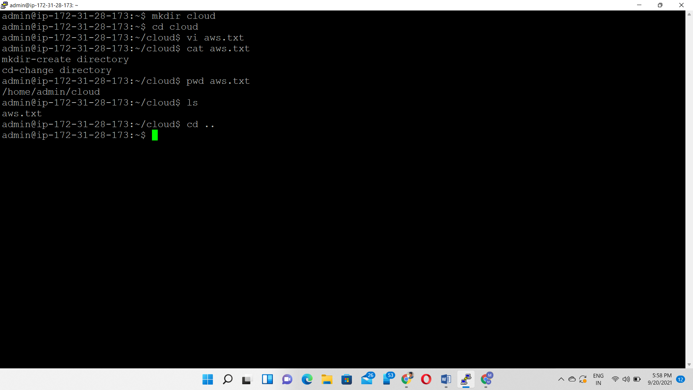

**rmdir**🡪delete (or) remove the empty directory

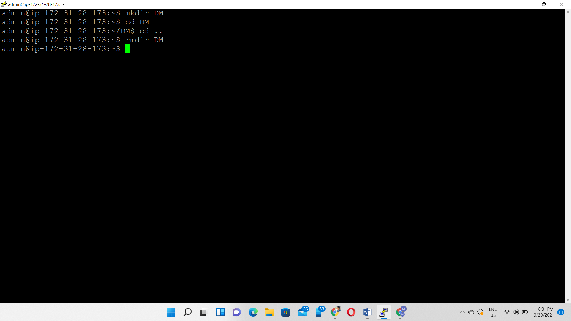

**find**🡪 locate files within a given directory.

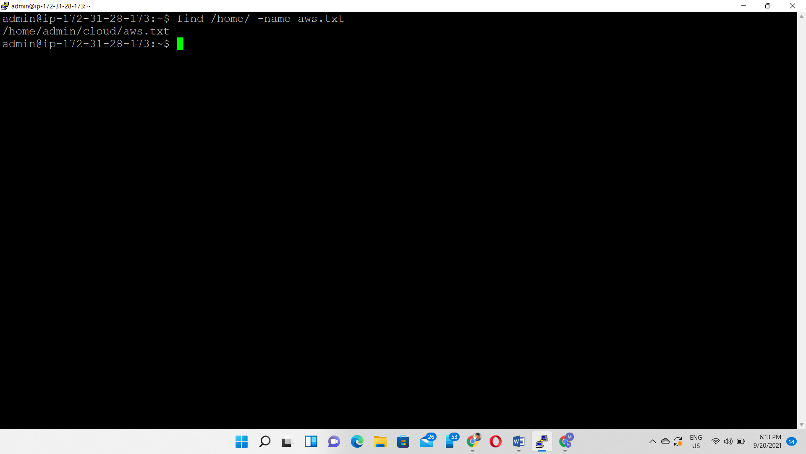

**Du –h**🡪 du means check how much space a file or a directory takes

-h means see it in bytes, kilobytes, and megabytes

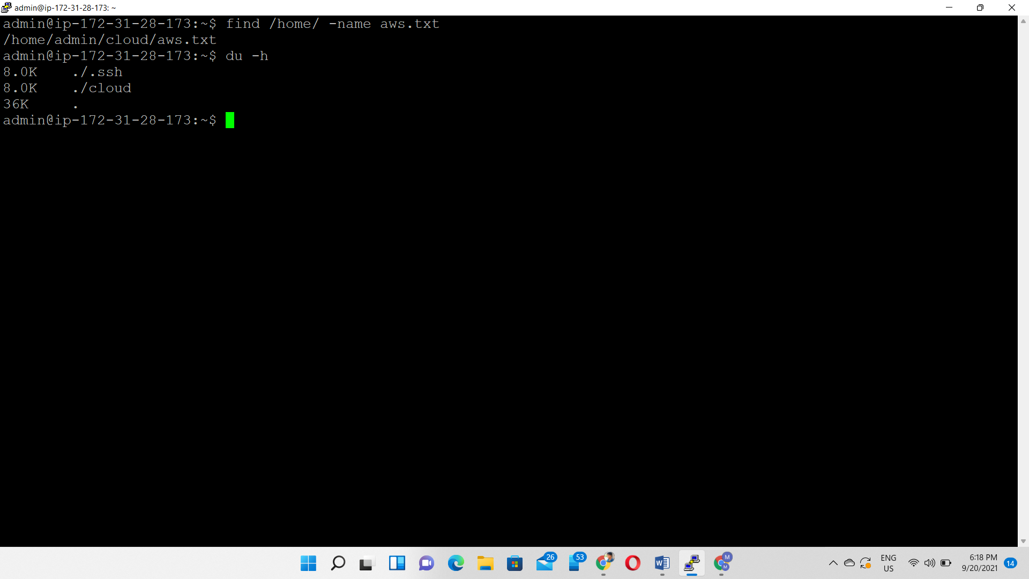

Ping🡪check connectivity status to a server

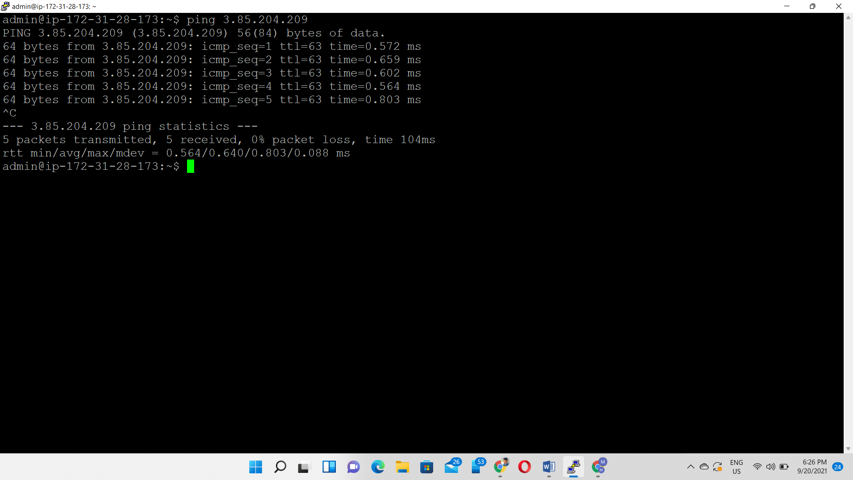

History🡪 When you’ve been using Linux for a certain period of time, you’ll quickly notice that you can run hundreds of commands every day. As such, running **history** command is particularly useful if you want to review the commands you’ve entered before.

